# Theoretical question:

1. We will prove that $H_{ball}$ is PAC learnable in the realize case:

Because we assume realizability, there is $h_{R^{*}}∈H_{ball}$ s.t $Y=h_{R^{*}}(X)$.

This means that every positive label samples are inside some ball with radius $R^{*}$.

We will propose the next algorithm $A_{ball}:$

Given samples $S$ drawn i.i.d from $R^{d}×\left\{0, 1\right\}, A_{ball}$ do the following:

1. Find the maximal $l_{2}$ norm of a positive labeled sample in $S$.
2. Return the hypothesis $h_{R}∈H_{ball}$ that corresponds to the maximal norm.

In another words, $A_{ball}$ returns the smallest ball that contains positive samples in $S$.

We know that it exists because we assumed realizability.

We now prove that $H_{ball}$ is PAC using $A_{ball}$:

Let there be samples $S={\left\{\left(x_{i},y_{i}\right)\right\}}_{i=1}^{n}$ drawn i.i.d from $R^{d}×\{0, 1\}$ with size $n$, $ϵ,δ∈(0, 1)$, and a reliable distribution $P$.

We mark $h_{R}≝A_{ball}(S)$ to be the hypothesis $A_{ball}$ returned.

$h_{R}$ can mistake only by labeling positive samples as negative (due to realizability).

If we denote $B_{R}$ the d-dimensional ball with radius d, we receive that:

$$e_{p}\left(h_{R}\right)=P\left[B_{R^{*}}\backslash B_{R}\right]$$

I will assume that $P\left[B_{R^{*}}\backslash B_{R}\right]>ϵ$ (otherwise we have nothing to prove).

We will define a strip $T$ ranging from $B_{R^{*}} to B_{R}$ in the following way:



Where $T$ is the green strip, the larger ball is $B_{R^{*}}$, and the smaller ball is $B_{R}$.

Because $P$ is continuous, we can take $T$ s.t $P\left[T\right]=ϵ$.

We notice that if there is $x_{i}$ s.t $x_{i}∈T$, then $B_{R^{*}}\backslash B_{R}⊂T$.

Therefore, in this case $e_{p}\left(h_{R}\right)=P\left[B_{R^{*}}\backslash B_{R}\right]≤P\left[T\right]=ϵ$.

This means that $e_{p}\left(h_{R}\right)>ϵ$ implies that $∀1≤i≤n, { x}_{i}∉T$.

Hence:

$$P\left[e_{p}\left(h_{R}\right)>ϵ\right]≤P\left[∀1≤i≤n, x_{i}∉T\right]=\prod_{i=1}^{n}{P\left[x_{i}∉T\right]}=P{\left[x∉T\right]}^{n}$$

Where the last two equalities holds because $S$ is drawn i.i.d.

From the definition of $T$, $P\left[x∉T\right]=1-ϵ$.

So:

$$P\left[e_{p}\left(h_{R}\right)>ϵ\right]≤{\left(1-ϵ\right)}^{n}≤e^{-ϵn}<δ$$

And to achieve that:

$$e^{-ϵn}<δ⇔e^{ϵn}>\frac{1}{δ}⇔n>\frac{ln\frac{1}{δ}}{ϵ}$$

This means that the sample complexity $m_{h}$ is bounded by $\left\lceil \frac{ln\frac{1}{δ}}{ϵ}\right\rceil$.

We can see that the sample complexity does not depend over the dimension d.

$⇒$

Let’s assume that $H$ is PAC learnable, we will prove that $H$ is PAC learnable in expectation.

Because $H$ is PAC learnable, there is $m_{h}:{\left(0, 1\right)}^{2}→N$ and an algorithm $A$ s.t for any distribution $P$ realizable w.r.t $H$, and any sample space $S$ with $\left|S\right|≥m_{h}\left(ϵ,δ \right)$, $P\left[e_{p}\left(A\left(S\right)\right)>ϵ\right]<δ$.

Let there be $a∈(0, 1)$.

Because $H$ is PAC learnable it follows that for sample space $S$ with $\left|S\right|≥m_{h}\left(\frac{a}{2},\frac{a}{2} \right)$, $P\left[e_{p}\left(A\left(S\right)\right)>\frac{a}{2}\right]<\frac{a}{2}$.

Using the law of total expectation:

$$E\left[e_{p}\left(A\left(S\right)\right)\right]=E\left[e_{p}\left(A\left(S\right)\right)|e_{p}\left(A\left(S\right)\right)>\frac{a}{2}\right]P\left[e_{p}\left(A\left(S\right)\right)>\frac{a}{2}\right]+E\left[e_{p}\left(A\left(S\right)\right)|e_{p}\left(A\left(S\right)\right)≤\frac{a}{2}\right]P\left[e_{p}\left(A\left(S\right)\right)≤\frac{a}{2}\right]$$

We know that $P\left[e_{p}\left(A\left(S\right)\right)>\frac{a}{2}\right]<\frac{a}{2}$ from PAC, and it follows that $E\left[e_{p}\left(A\left(S\right)\right)|e_{p}\left(A\left(S\right)\right)≤\frac{a}{2}\right]≤\frac{a}{2}$ because the expected value of $e_{p}\left(A\left(S\right)\right)$ given that $e_{p}\left(A\left(S\right)\right)≤\frac{a}{2}$ is at most $\frac{a}{2}$.

Thus

$$E\left[e_{p}\left(A\left(S\right)\right)\right]≤E\left[e_{p}\left(A\left(S\right)\right)|e_{p}\left(A\left(S\right)\right)>\frac{a}{2}\right]\frac{a}{2}+\frac{a}{2}P\left[e_{p}\left(A\left(S\right)\right)≤\frac{a}{2}\right]$$

We know that $P\left[e_{p}\left(A\left(S\right)\right)≤\frac{a}{2}\right]≤1$, and $E\left[e_{p}\left(A\left(S\right)\right)|e_{p}\left(A\left(S\right)\right)>\frac{a}{2}\right]≤1$, because all probabilities are bounded by 1, therefore we conclude that

$$E\left[e_{p}\left(A\left(S\right)\right)\right]≤\frac{a}{2}+\frac{a}{2}=a$$

If we define $N:\left(0, 1\right)→N, N(a)=m_{h}(\frac{a}{2},\frac{a}{2})$ we will get that $H$ is PAC learnable in expectation with the same algorithm $A$.

$⇐$

Let’s assume that $H$ is PAC learnable in expectation, we will prove that $H$ is PAC learnable.

Because $H$ is PAC learnable in expectation, there is an algorithm $A$ s.t for PAC in expectation assumption holds.

Let there be $ϵ,δ∈\left(0, 1\right)$.

We need to find out $m_{h}:{\left(0, 1\right)}^{2}→N$ s.t for any distribution $P$ realizable w.r.t $H$, and any sample space $S$ with $\left|S\right|≥m_{h}\left(ϵ,δ \right)$, $P\left[e_{p}\left(A\left(S\right)\right)>ϵ\right]<δ$.

Using the Markov inequality (I assume that the loss function range is $R^{+}$):

$$P\left[e_{p}\left(A\left(S\right)\right)>ϵ\right]≤\frac{E\left[e_{p}\left(A\left(S\right)\right)\right]}{ϵ}$$

If we take $S$ s.t $\left|S\right|≥N\left(\frac{ϵδ}{2}\right)$ (because $ϵ,δ∈\left(0, 1\right), ϵδ∈\left(0, 1\right)$)

we will get that

$$E\left[e_{p}\left(A\left(S\right)\right)\right]≤\frac{ϵδ}{2}$$

Hence $P\left[e_{p}\left(A\left(S\right)\right)>ϵ\right]≤\frac{E\left[e_{p}\left(A\left(S\right)\right)\right]}{ϵ}≤\frac{ϵδ}{2ϵ}<δ$

So, if we define $m_{h}:{\left(0, 1\right)}^{2}→N, m_{h}\left(ϵ,δ\right)=N\left(ϵδ\right)$ we will get that $H$ is PAC learnable with the same algorithm $A$.

1. We will prove that the VC-dimension of $H_{k}$ is $2k$:

To show that we I will show for all $k$, there is a set of size $2k$ that shattered by $H_{k}$,

And prove that $VCdim\left(H_{k}\right)<2k+1$.

$Lemma:$ $VCdim\left(H_{k}\right)<2k+1$

$Proof:$ By contradiction, assume that $VCdim\left(H_{k}\right)≥2k+1$.

So, there is a set $C={\left\{x_{i}\right\}}_{i=1}^{2k+1}$ of size $2k+1$ that $H_{k}$ shatters.

W.l.o.g we assume that $x_{1}<x_{2}<…<x_{2k+1}$.

For $1≤i≤2k+1$, we define $s_{i}=\left\{\begin{aligned}1 i is odd, \\ 0 i is even\end{aligned}\right\}$. Let us look on ${s≝\left\{s_{i}\right\}}_{i=1}^{2k+1}$.

Let there be the hypothesis $h∈H_{k}$ that achieves $s$.

We denote $h=\left\{\left[l_{1},u_{1}\right],…,\left[l_{k},u_{k}\right]\right\}, 0≤l_{1}≤ u_{1}≤l_{2}≤u_{2}≤ … ≤u_{k}≤ 1\}$.

We can see that $\left|\left\{1≤i≤2k+1 ∣ s_{i}=1\right\}\right|=k+1$, so by pigeonhole principle there must be $1≤i<j≤2k+1$ s.t $x_{i},x_{j}∈\left[l_{m},u_{m}\right]$ for $m∈\left\{1, …, k\right\}$.

From the definition of $s$, it follows that $j>i+1$, therefor because $h\left(x_{i}\right)=1,$ follows that $h\left(x_{i+1}\right)=0$. But because $x_{i}<x_{i+1}<x_{j}$, it follows that $x_{i+1}∈\left[l_{m},u_{m}\right]$, and this is contradiction. $Lemma:$ $VCdim\left(H_{k}\right)≥2k$

To do I will claim the next proposition:

$Lemma$**:** Let there be $\left(s_{1},…, s_{2n}\right)∈{\left\{0, 1\right\}}^{2n},$ then the number of maximal chains of 1’s is at most n.

Given $\left(s_{1},…, s_{n}\right)∈{\left\{0, 1\right\}}^{n},$ a **chain of 1’s** is a sequence of consecutives 1’s. E.g., in (1,1,0,1) we have 4 chains of 1’s:

* (1,1) in positions 1 and 2
* (1) in position 1
* (1) in position 2
* (1) in position 4

I will call a chain maximal if it’s not part of another chain. In the previous example we have 2 maximal chains:

* (1,1) in positions 1 and 2
* (1) in position 4

$Proof$**:**

For $n=1$:

We can see that ${\left\{0, 1\right\}}^{2}=\left\{\left(0, 0\right), \left(0, 1\right), \left(1, 0\right), \left(1, 1\right)\right\}$, and the maximal number of chains of 1’s is indeed $n=1$ (in $\left(0, 1\right)$ and $\left(1, 0\right)$ and $\left(1, 1\right)$ we can see a maximal chain with length 1).

Assuming the induction assumption for $n-1$, now we will prove for $n$:

Let there be $s=\left(s_{1},…,s_{2n-2}, s_{2n-1}, s_{2n}\right)∈{\left\{0, 1\right\}}^{2n}.$

According to the induction assumption, the maximal number of chains of 1’s in $\left(s_{1},…,s_{2n-2}\right)$ is at most $n-1$.

If $s_{2n-2}=0$ then we can have only one more maximal chain (by

$\left(s_{2n-1}, s_{2n}\right)∈\{\left(1,0\right), \left(0,1\right), \left(1,1\right)\})$, thus, the number of maximal chains in

$s$ is at most $n$.

If $s_{2n-2}=1$ then we can create only one more maximal chain (by

$\left(s_{2n-1}, s_{2n}\right)=\left(0,1\right))$, thus, the number of maximal chains in $s$ is at most $n$.

Now we will prove that $VCdim\left(H_{k}\right)≥2k$

$Proof:$ let there be a set $C={\left\{x_{i}\right\}}_{i=1}^{2k}$ s.t $x_{1}<x_{2}<…<x_{2k}$.

Let there be $\left(s_{1},s_{2},…, s_{2k}\right)∈2^{2k}$, we will show that

there is $h∈H_{k}$ s.t $∀ 1≤i≤2k, h\left(x_{i}\right)=s_{i}$.

We will define the parameter of $C$ to be $Δ\left(C\right)≝\min_{x, y∈C}\left|x-y\right|$

Using the above lemma, we know that the number of maximal chains of 1’s in $s$ it at most $k$.

Let us call the set $Ch=\left\{c ∣ c is maximal chain in C\right\}$ as the set of maximal chains.

We will create interval that fits to a maximal chain:

given $c=\left(s_{i},…,s_{j}\right)∈Ch$:

if $\left|c\right|=1$: we will create the interval $I_{c}=\left[\max_{}\left\{0, x_{i}-\frac{Δ\left(C\right)}{3}\right\} ,\min\left\{1, x_{i}+\frac{Δ\left(C\right)}{3} \right\}\right] .$

if $\left|c\right|>1$: we will create the interval $I_{c}=\left[\max_{}\left\{0, x_{i}-\frac{Δ\left(C\right)}{3}\right\} ,\min\left\{1, x_{j}+\frac{Δ\left(C\right)}{3} \right\}\right] .$

We can see that the intervals we created are disjoint.

From cardinality concerns, we can find more $k-|Ch|$ intervals in $[0, 1]$ s.t no element from $C$ is in them and disjoint from the intervals we already created.

Let us define the set of them $h'$.

So, if we define $h=\bigcup_{c∈Ch}{I_{c}}∪h'$ we can see that $∀ 1≤i≤2k, h\left(x_{i}\right)=s_{i}$, as required, therefore $VCdim\left(H_{k}\right)≥2k$.

1. We will prove that the VC-dimension of $H_{polly}$ is $∞$:

Let there be $C={\left\{\left(x_{1}^{i}, x_{2}^{i}\right)\right\}}_{i=1}^{n}⊂R^{2}$ set of n points.

We will show that $H_{polly}$ shatters $C.$

Let there be $\left(s_{1},s_{2},…, s_{n}\right)∈{\left\{0, 1\right\}}^{n}$.

Let us define $C^{'}={\left\{\left(x_{1}^{i}, x_{2}^{i}-{(1-s}_{i})\right)\right\}}_{i=1}^{n}$.

If we consider the Lagrange polynomial $L$ for $C'$ we will see that:

If $s_{i}=1$: $L\left(x_{1}^{i}\right)=x_{2}^{i}-{(1-s}_{i})=x_{2}^{i}-(1-1)=x_{2}^{i}≥x_{2}^{i}$

Hence $h_{L}\left(x_{1}^{i}, x_{2}^{i}\right)=1$

If $s_{i}=0$: $L\left(x_{1}^{i}\right)=x_{2}^{i}-{(1-s}_{i})=x_{2}^{i}-(1-0)=x_{2}^{i}-1<x_{2}^{i}$

Hence $h_{L}\left(x_{1}^{i}, x_{2}^{i}\right)=0$

Therefore, for all $1≤i≤n,$ $h_{L}\left(x_{1}^{i},x_{2}^{i}\right)=s_{i}$

We saw that for every $n$, $H_{polly}$ shatters a set $C⊂R^{n}$ of size $n$, thus $VCdim\left(H_{polly}\right)=∞$

# Programming Assignment:

1. As we studied in class, in classification problems, the optimal hypothesis (which minimizes the true error) is:

$$h\left(x\right)=1⇔P\left[Y=1 \right| X=x]≥P\left[Y=0 \right|X=x]$$

i.e.,

$$h\left(x\right)=1⇔P\left[Y=1 \right| X=x]≥\frac{1}{2}$$

We will define $h∈H_{10}$ s.t applies to the bayes optimal predictor rule:

Thus, if $x∈\left[0, 0.2\right]∪\left[0.4, 0.6\right]∪[0.8, 1]$, we should label it as positive, and if

$x∈(0.2, 0.4)∪(0.6, 0.8)$, we should label it as negative.

Hence, we construct $h^{*}∈H_{10}$:

$$h=\{\left[0, 0.1\right], \left[0.1, 0.2\right], \left[0.4, 0.45\right], \left[0.45, 0.5\right], \left[0.5, 0.55\right],$$

$$\left[0.55, 0.6\right], \left[0.8, 0.85\right], \left[0.85, 0.9\right], \left[0.9, 0.95\right], [0.95, 1]\}$$

And $h^{*}∈argmin_{h∈H_{10}}E\left[e_{p}\left(h\right)\right]$.

Let’s calculate the true error of h:

Let’s denote $Ω=\left[0, 1\right]×\{0,1\}$

$$e_{P}\left(h\right)={E[Δ}_{zo}\left(h\left(X\right), Y\right)]=P\left[h\left(X\right)≠Y\right]$$

$$=P\left[\left\{\left(x, y\right)∈Ω ∣ h\left(x\right)≠y\right\}\right]$$

$$=P\left[\left\{\left(x, 0\right)∈Ω ∣ h\left(x\right)=1\right\}\right]+$$

$$P\left[\left\{\left(x, 1\right)∈Ω ∣ h\left(x\right)=0\right\}\right]$$

$$=P\left[\left\{\left(x, 0\right)∈Ω ∣ x∈\left[0, 0.2\right]∪\left[0.4, 0.6\right]∪\left[0.8, 1\right]\right\}\right]+$$

$$P\left[\left\{\left(x, 1\right)∈Ω ∣ x∉\left[0, 0.2\right]∪\left[0.4, 0.6\right]∪\left[0.8, 1\right]\right\}\right]$$

$$=P\left[Y=0\right|X∈\left[0, 0.2\right]∪\left[0.4, 0.6\right]∪\left[0.8, 1\right]P\left[X∈\left[0, 0.2\right]∪\left[0.4, 0.6\right]∪\left[0.8, 1\right]\right]+$$

$$P\left[Y=1 | X∈\left(0.2, 0.4\right)∪\left(0.6, 0.8\right)\right]P\left[X∈\left(0.2, 0.4\right)∪\left(0.6, 0.8\right)\right] \\ =0.2*0.6+0.1*0.4=0.16$$

1. 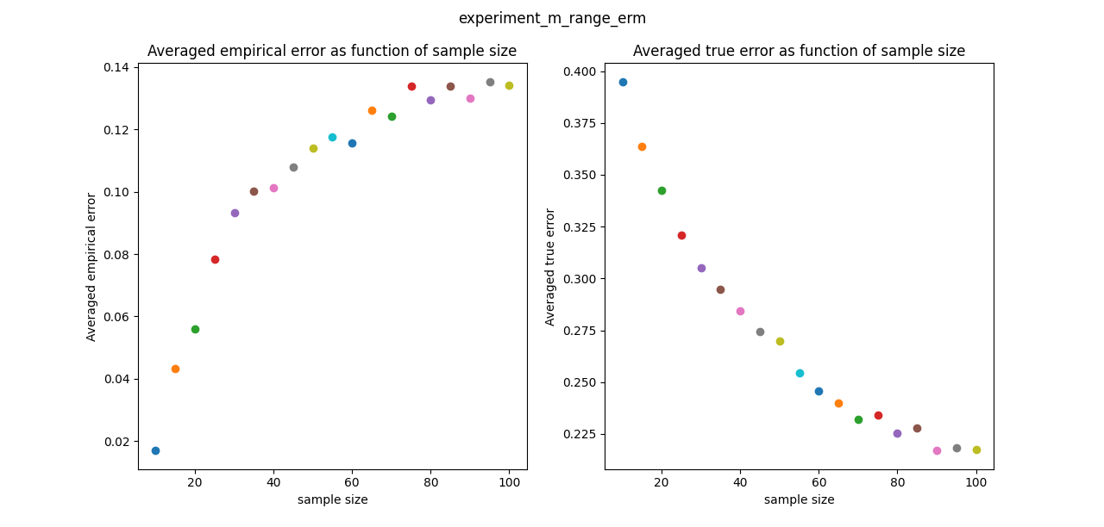

We can see 2 results from our experiment:

* The averaged true error decreasing as the sample size increasing
* The averaged empirical error increasing as the sample size also increasing

The fact that the true error decreasing is not surprising, because we proved in the theoretical question that the $VCDim$ of $H_{k}$ is finite, and this means that $H_{3}$ is Pac learnable in the agnostic case.

Therefore, the true error of the hypothesis returned by ERM should converge to the best true error, which is $0.16$.

The increasing of the averaged empirical error as the sample size also increasing also makes sense. Because we are limited to only 3 intervals, as the sample size increase, we can’t have perfect fit for our samples.

1. 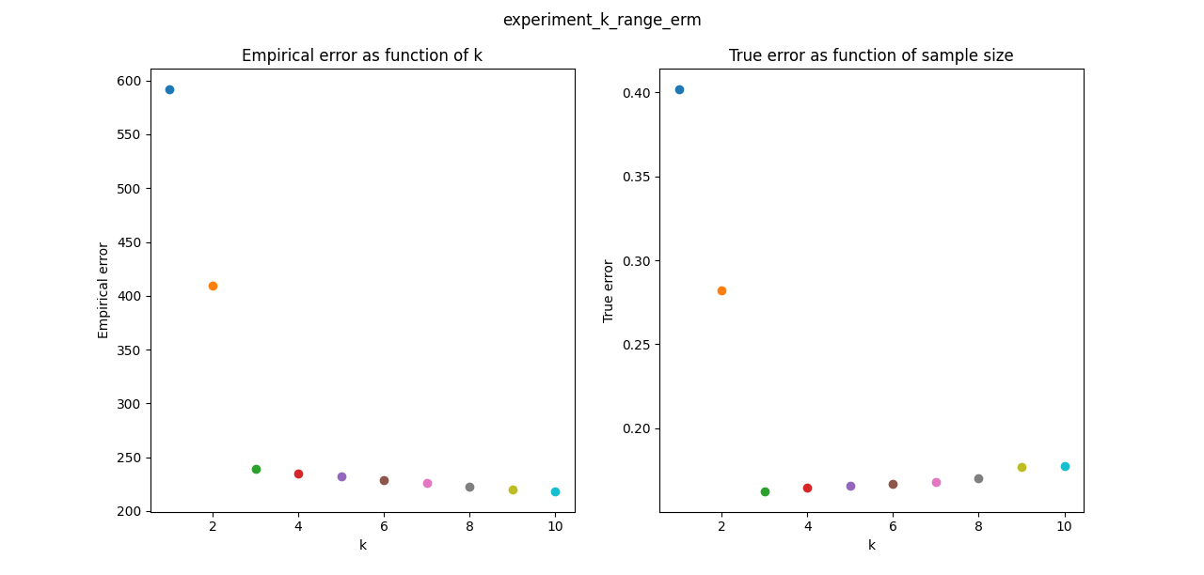

We can see 2 results from our experiment:

* The true error as a function of k is relatively small when k grows
* The empirical error decreasing as a function of k

The k that minimizes the empirical error is $k=10$, but $h_{ERM_{10}}$ has large true error compared to another k’s.

1. 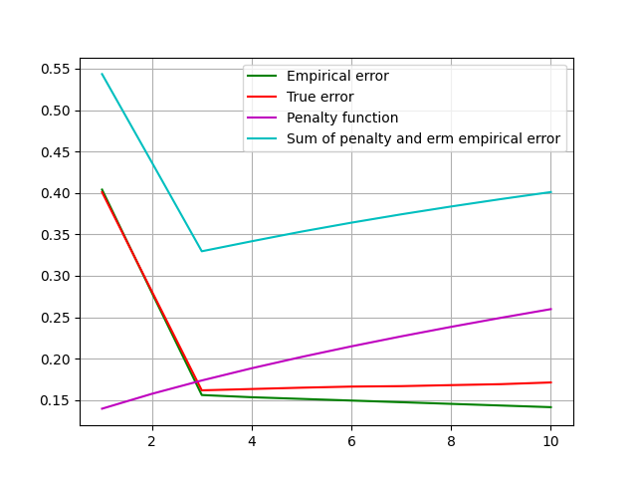

The k that minimizes the sum of the penalty function and the empirical error is

$k=3$, and we can see that, ${e_{p}(h}_{ERM_{3}})$ indeed is the smallest one, which is better from the value of k we choose in the last article.

The SRM gave a tighter bound to the true error.

1. 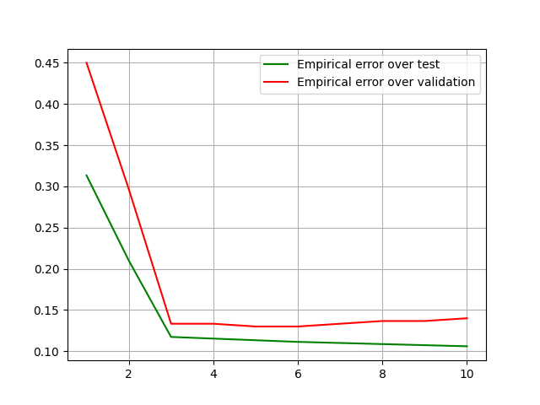  
     
   Running the holdout-validation process a few times gave me different results occasionally. For example, in one session of learning, the chosen hypothesis was with $k=5.$

In another session of learning, the chosen hypothesis was with $k=3$,

Which is the hypothesis with best true error.

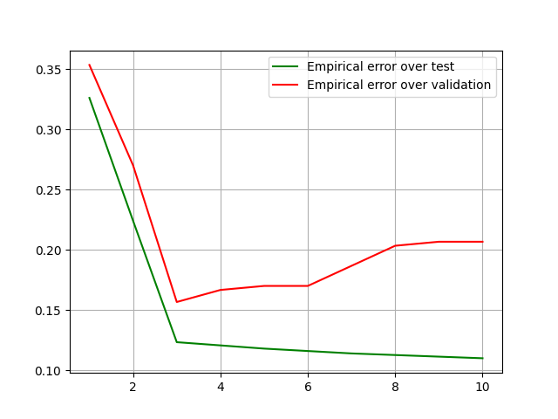

We can see that indeed the holdout-validation process indeed managed to give a better hypothesis, without knowing strict bounds over our hypothesis classes.